**Gordo Bot**



*Critical Design Review*

Team 6

Zachary Laguna

Raney Ankele

Reid Morse

Cody Nguyen

Thomas “Jake” Rod

Nicholas Soliman

Department of Computer Science

Texas A&M University

03/23/22

Table of Contents

Introduction 2

Needs statement 3

Goal and objectives 3

Design constraints and feasibility 3

Proposed design 5

System description 6

Complete module-wise specifications 7

Project management 12

Updated implementation schedule 13

Updated Validation and Testing Procedures 14

Updated division of labor and responsibilities 15

Preliminary results 16

# Introduction

Cooking at home has become more appealing these days as covid-19 frightens the populous and healthy, home-cooked meals become an appealing alternative to greasy take-out food. According to a new study by Hunter, a consumer market research firm, 71% of people in the U.S. say that they will continue to cook at home after the end of the pandemic. However, consumer culture has promoted that ordering takeout or using Uber Eats and DoorDash are more efficient methods of procuring sustenance, thus producing sub-optimal cuisine from our stay-at-home chefs. [1]

## Needs statement

The study goes on to find that about 25% of these cooks are learning more and building confidence in the kitchen, and almost another 25% are just as confident as they have always been. The latter could be some that were always confident or some that were never confident, implying that some of these cooks could still struggle with some of the basic steps when cooking at home. Following a recipe with precise and intricate steps can be difficult for new cooks when dishes increase in complexity, and measuring ingredients takes time and practice. What can be done to assist amateur chefs in the kitchen who are intimidated by long recipes and struggle measuring ingredients? [1]

## Goal and objectives

This project aims to assist amateur cooks with prepping and preparing recipes so that the cook can focus on the actual cooking rather than the gathering, measuring, and mixing of ingredients. Tedious parts of cooking should be automated. With this in mind, there are several objectives planned to achieve this goal.

At the minimum, our project should be able to pull and display recipes to the user through some interface, whether that is with a screen on the device or a webapp. We would start with hand selected recipes. This should be handled by a Raspberry Pi on the device, communicating with some web server/database or locally hosting this information.

The robot should be able to understand a recipe’s requirements and dispense the ingredients with correct measurements into a container. The ingredient selection will be handled by some servo controlled by the Raspberry Pi, and the measurement of ingredients will be handled by sensors (either by weight and/or flow rate). The robot can be expected to perform this task in a kitchen at a reasonable pace (faster than manually measuring and mixing ingredients).

Ideally, recipes could be scraped from the internet (assuming the recipes are publicly available to use) and stored in a cloud database. These recipes would be parsed and measurements would be formatted for the Raspberry Pi to understand and use as instructions for the various sensors on the device. A search option could be implemented to easily find different recipes. Options could be chosen using voice commands.

There are objectives that are not a top priority such as implementing simple accounts that would allow users to save recipes and provide them with recommendations or keeping track of how much of each ingredient a user has and reminding them to get some more.

## Design constraints and feasibility

The constraint to take into consideration is space. Counter space in a kitchen is limited, so the device should not be larger than the average kitchen appliance. The general goal of the project is achievable with a servo, Raspberry Pi, and sensors, however, the efficiency and accuracy of these devices in our particular application is unknown. Each device will have a range of accuracy that needs to be accounted for. Recipes that require precise/small measurements may not be achievable without higher (expensive) sensors or fine-tuning. Experimenting will need to be done to understand the limitations of the sensors.

Another limitation of the hardware will be the speed to choose, measure, and dispense the ingredients. The weight of all the ingredients will put some strain on the servo, so a servo must be chosen within the budget that can handle the weight of the ingredients.

Powering all the devices must be considered as well, the GPIO of a Raspberry Pi may not be able to handle all the interfacing of the devices, so an external power solution should be considered.

The total cost of the device is not expected outside of the budget, but the time frame this project is produced will limit how much can be done with the device. The minimum objective stated previously should easily be achieved, but the amount of time remaining will dictate the “stretch goals” of the project.

* 1. **Validation and testing procedures**

To validate and test the system as a whole, we will perform a three stage validation process. The first stage of this process is an initial stage where the device is asked to perform a simple user task. This stage is taken slowly, checking every component’s behavior along the way. The next stage is considered a controlled user case, where the device is given full, but simple, recipes from the user. The system is viewed as a whole such that the user input should provide the correct output on the hardware end. Only when there is a failure will the system be looked at in terms of components. The final stage is the “real use” case stage. The system will undergo validation that simulates how a user would actually use the device, along with giving and interviewing random users about their thoughts after trying the device.

# 

# Proposed design

* 1. **Updates to the proposal design**

The device has been redesigned to accommodate some limitations noticed since the initial design.

|  |  |
| --- | --- |
| 1. Original Design | 1. Updated Design |

The original design was top-heavy, a thin disk with several canisters of ingredients would be difficult to balance, especially with the variance between the weight of ingredients. There would be too much strain on the center servo. So, the rotational component is now supported around most of the device. This should lessen the strain on the servo when selecting ingredients and means the user does not need to balance the ingredients. The larger base also allows for more room to wire the electronics, compared to the previous design, where circuitry would need to be very tight.

The original design also only included a single flow sensor, however this convoluted the design as the switching of the flow sensor between ingredients needed to be accounted for. The new design uses individual flow sensors for each liquid ingredient. With this change, the design is simplified and cross contamination is reduced.

|  |
| --- |
| Solid dispenser |

A simple flow regulator does not work well for all solid ingredients, so the solid ingredient dispenser was redesigned such that ingredients are actively pushed out. The downside here is additional expenses and wiring for the motors that move the ingredients out. However, this provides a higher quality experience for the end user, since ingredients will be less likely to get stuck.

## System description

The figure below shows the high-level block diagram of the system.

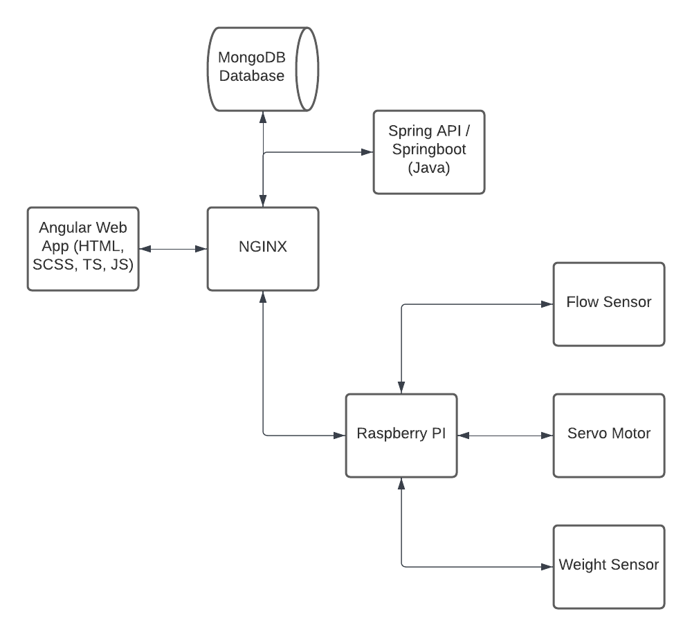

Nginx is an open source software used for web serving and acts as a reverse proxy for backend content. Nginx uses a master thread to create worker threads to serve web pages. Through the Nginx webserver, the user interface and raspberry pi can access information that is stored in the database and interact with the hardware.

The database will use MongoDB to store information regarding the recipes a user can make and information regarding the user’s device. Recipes will be broken down into each instruction into lists of ingredients and appliances with values and specifications for each so that the raspberry pi can communicate what needs to be done effectively to both the user and the hardware.

The user will interact with the device by using the Angular web application. The user will be able to add and remove recipes from the database, select a recipe to begin cooking, and cycle through the instructions. The user will also be able to tell the device to perform a measurement and dispense an ingredient if applicable.

The hardware utilizes a raspberry pi as the primary controller of the hardware. Using the IO pins, the pi will control a flow sensor, a weight sensor, and a servo motor to measure and dispense ingredients according to the instructions it receives from the user. The flow sensor is used to dispense liquid ingredients from the compartments of the device. This sensor measures the flow of a liquid and stops dispensing once the required amount of liquid has been dispensed. The weight sensor is used to measure solid ingredients from the compartments of the device. This sensor measures the weight of a solid and stops dispensing once the required amount has been dispensed. The servo motor is used to rotate a wheel of ingredients. The raspberry pi will have a set position of the location that an ingredient is dispensed and will rotate the wheel until the correct ingredient is at this location. The wheel will be represented by an array in software and will store which ingredient is located in each compartment, whether the ingredient is a liquid or a solid, and whether the compartment is not known to contain an ingredient. The user will have to set the ingredient locations using the device or the web application.

## Complete module-wise specifications

**Sensors**

All the electronics will be housed within the updated design that will be 3D-Printed.

A high level design of the circuit and parts list is pictured below:

| | **Item** | **Count** | | --- | --- | | Raspberry Pi | 1 | | Servo Motor (high torque) | 1 | | Motor | 3 | | Wires | 1 | | Wire Stripper | 1 | | Plexiglass | 3 | | 1Kg Filament Roll (For base) | 1 | | Soldering Kit | 1 | | Flow Meter | 2 | | Weight Sensor | 1 | | Power Supply | 1 | | High level circuit design |
| --- | --- | --- | --- | --- | --- | --- | --- | --- | --- | --- | --- | --- | --- | --- | --- | --- | --- | --- | --- | --- | --- | --- | --- | --- | --- |

As seen in the diagram, the Raspberry Pi is the central control system of the device. All the sensors, motors, and servos are connected to the GP/IO of the Raspberry Pi. This is done through CircuitPython. The Raspberry Pi also is the interface between the user, server/database, and IO. However, the power output of the Raspberry Pi cannot provide enough power to control all devices, so an external power supply is used to power the Pi and IO.

In the prototype, there will be two liquid ingredients, three dry ingredients, and a scale on the base.

The liquid ingredients will be kept within a Water Bottle with a flow controller/ flow sensor. The Pi calculates the flow rate of the liquid and cuts off the liquid when the required amount has been dispensed.

Solid ingredients are in a container with a rotating mill that rotates to dispense ingredients. Measuring requires a couple steps: First, the scale must save the current weight as a reference. Then, the device starts rotating the mill to dispense the ingredient. While this is occurring, the Pi monitors the weight, checking if the difference between the current weight and reference weight is equal to the desired weight. Once this occurs, the mill stops.

For ingredient selection, the Pi receives an input file from the server and parses the ingredients. The position of each ingredient is stored, and a large servo in the center rotates accordingly.

**Database Collections**

Below are the database collections that will be used to organize recipes so that the device will be able to perform operations with the sensors.

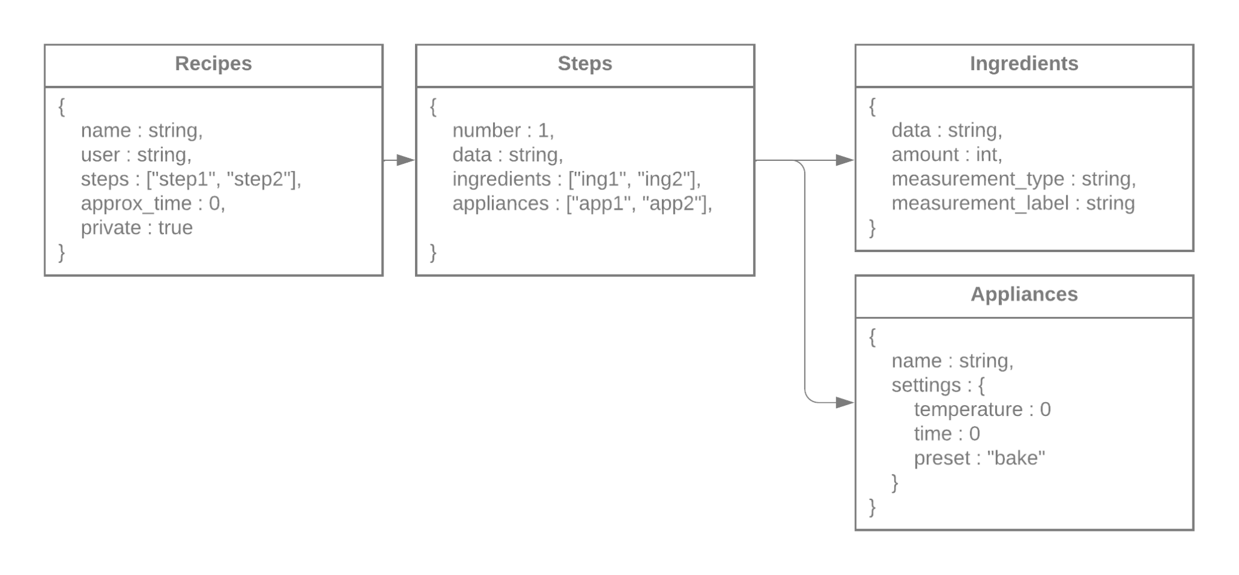

These collections are also used to assist the user in tracking the steps and instructions of a recipe including the time required for a particular step. Each appliance may or may not have different settings regarding time, temperature, or other parameters related to its use. Each ingredient will have an amount. Complex steps must be broken down into simple instructions that can be done sequentially. Recipes will be tied to the user who added them, meaning that currently, one user per device.

**API**

The design of the API will consist of services/functions that can be called in order to connect the bridge between the front end web user interface and the backend calculation / production function.

An example of this API design in action is outlined below

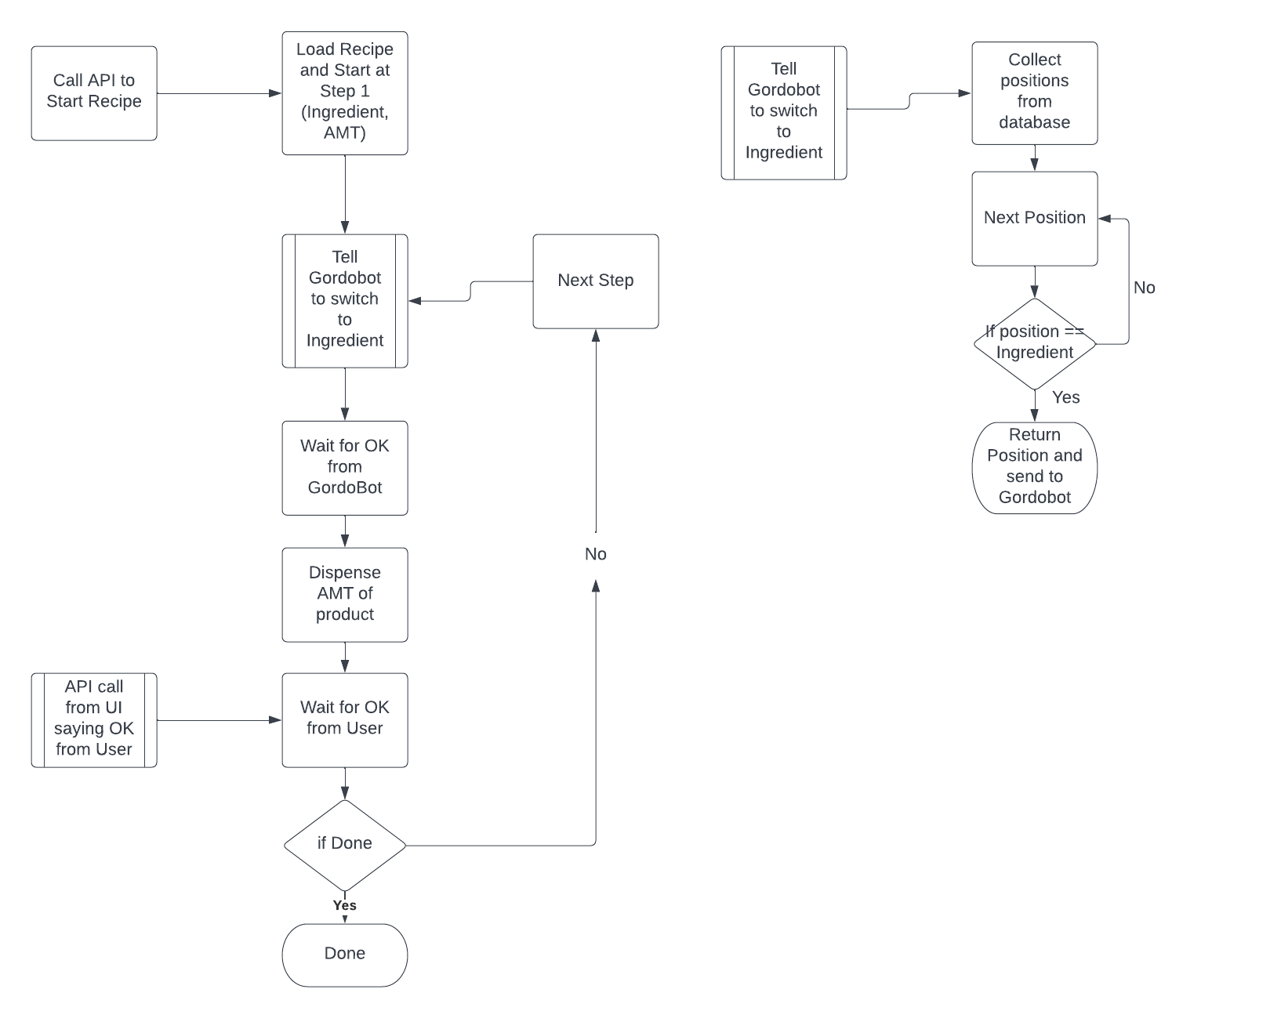

We will implement our API using a technology called Spring boot. Spring framework is arguably one of the most popular application development frameworks used by java developers. All the components of the spring framework are glued together by the dependency injection architecture pattern. Spring boot automates the process of setting up Spring application (which can become tedious). Spring boot enables java developers to quickly start a new project with all the required spring framework components.

**UI**

The brainstormed picture looks something like the image below. Since we’re not entirely sure yet whether using an API is best, and haven’t been able to test to confirm the current front runner chosen, we’ve tried to design a more general look and functionality that does not require API specifics. The database interactions should be running behind the scenes and not appear too much on the UI. Additionally, we aimed for a design that could be easily implemented on a screen attached to our product or as an independent application interface, so it can be adapted quickly in case of development adaptations. This means that the shapes and organizations were sketched out to be as clean and simple as possible while still retaining appeal.

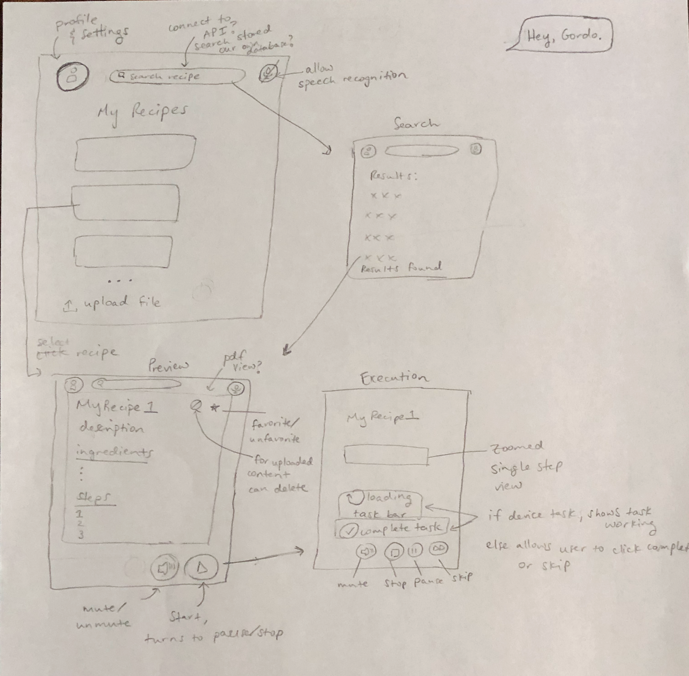

The basic functionality and framework notes were included. The writing is a bit hard to see in the image, but the point still gets across. As for the profile and settings drop down, it would depend on the interaction with our database and API and will be finalized later. Here, it is not included in order to prevent possible tunnel vision in functionality. At this time, an upload file (ideally pdf) button is included, but may or may not be removed at a later date.

We chose to try a [Figma](https://www.figma.com/file/UpYtq7MbKZcAm6J79e1aGm/UI-GordoBot?node-id=0%3A1) (viewable with link) to demonstrate this. We haven’t done a Figma before; although it may be possible to create a working prototype, we’re not sure how, and it is a low priority as a demonstration can not be included here. The wireframe result is shown below. At this time the main pages are included and some button functionality is shown.

Upon opening, the home page will come up. It should be a guest-type profile connected to the device unless otherwise specified by a sign-in. A list of favorite recipes are shown, clicking the recipes would redirect them to the preview page, and at this time an upload function is scheduled to be available. On the top, profile and settings are accessed through the profile icon, the search bar can be used and taken to the search page, and the microphone icon can be toggled to allow speech recognition. On the search page, clicking a result would take it to the preview page, while the Back and Next buttons would scroll through results. The preview page has a back button going to the previous page, a star to toggle favorites, and a cancel button to delete personally uploaded files. The recipe details are listed as parsed by the program, with the option of an attached image. At the bottom is a start button which can be used to run the device with this recipe and a mute toggle option for reading steps aloud (that will transfer to the next page). The execution goes step by step, showing one at a time. It shows a task loading for tasks done by the device, and a mark complete for ones done by the user. The mute button is the same as the preview page, the stop button exits the program to go back to the preview page, and there is a skip button available for skipping tasks.

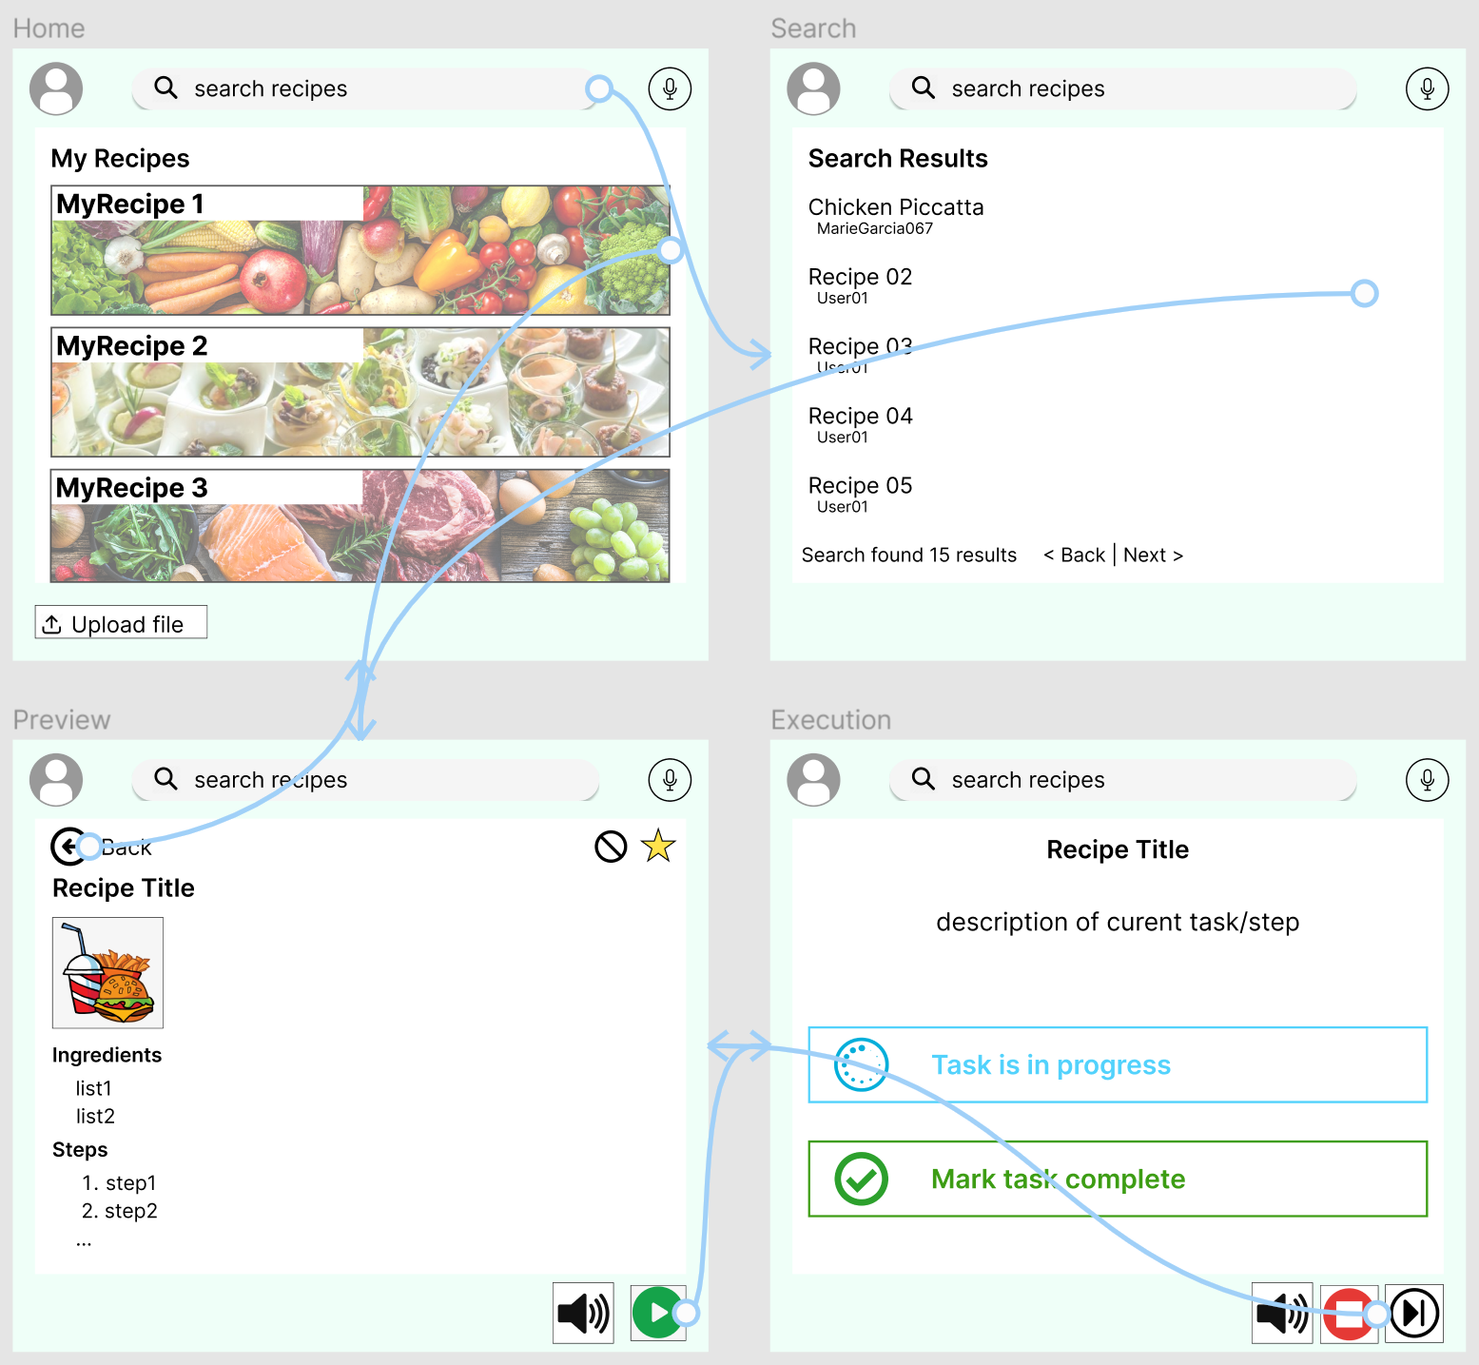

# 

# Project management

The following is a list of current roles and responsibilities that were set in the project proposal:

Zachary Laguna - API design along with finances and purchases and project management

Zachary Laguna is the Project Manager and the API design lead. He will be responsible for creating the API which translates user input into a signal that is passed into the device through a web server. This layer will make it possible for commands to be translated from the web into a physical device. Non technology-related, he will be responsible for any project management documentation, and any financial statements that must be created pertaining to this project. He will also be responsible for testing different components of the project to make sure they work in congruence with each other.

Raney Ankele and Nicholas Soliman - application software and user interface design

We mainly work independently from the team at this time. Although we do have discussion with the database, API, and actual computation program involved in our project there is a certain degree of uncertainty until things have been actually made and tested before integration. Right now we are researching and designing in parallel, making it hard for us to plan for the workings of the other sections very much. Instead, we chose to design as generically as possible, while keeping in mind our product’s base functionality and appeal.

Our brainstorming sessions sometimes included some discussion with other members, adjusting our design slightly. The main portion of it so far has focused on the discussion of ease of use, visual appeal, simplistic design, necessary features, and possible handicaps that could hinder the user’s experience. For example, how we think the user’s profile might save recipes, or how color blindness could affect experience.

We have reviewed a bit of the planned implementation of angular and ionic, but will start in earnest once we start putting the project together.

So far, this individualistic approach has been working fine, but once we actually start building everything, we must keep close attention to the progress of the other members. We will rely heavily on their input to attempt to make the user experience as smooth and painless as possible. Essentially, a large part of our job is to put these pieces together easily so that they can be used in a logical manner. The details and feedback from these other sections therefore will likely cause a lot of redesigns and adaptations to our current system; in comparison, the creation of the interface is much simpler.

At this time we have no hardware designs, purchase, technical reports, or testing. We will likely be working on these for the rest of our time with the feedback given to us.

Reid Morse - microcomputer systems

Reid will work closely with Cody in order to assemble the device but will mainly focus on the bridge between the cloud and the Raspberry Pi. He needs to translate the signal that comes in from the cloud into a series of commands that will instruct the device to perform a certain action.

Cody Nguyen - sensors and hardware design

Cody will be responsible for assembling the physical device with the help of Reid and installing the sensors to ensure they function correctly with the Raspberry Pi. Cody will essentially be working on the bridge between the Raspberry Pi and the device Hardware.

Thomas “Jake” Rod - server and database administration

Jake will be responsible for making sure data flows from the user interface through the web server into the device and vice versa. Essentially, Jake will be managing the cloud services which enables our product to be able to be used simultaneously by multiple devices. Jake will also be responsible for handling the database which stores information about recipes and measurement amounts. Jake is our recorder so he will be responsible for recording any meeting notes.

We are currently using google sheets to keep track of the tasks needed to be completed and the completion status. We plan on expanding this google sheet to include planned start date and completion date to ensure that these tasks do not consume too much time. We have a short amount of time for this project. Any chances for delay must be minimized and additional resources should be allocated to demanding tasks.

## Updated implementation schedule

The project schedule remains largely the same, with a few minor changes to adjust for the realities faced during implementation. An additional week was added to the time allocated for building the robot, the tasks of creating the Raspberry Pi web server and wrapper were combined, and the time for researching into speech recognition was pushed back a week to give more time to construct a working prototype for the rest of the project first. Both the schedule of tasks and the breakdown of the dependencies among them along with the critical path are pictured below.

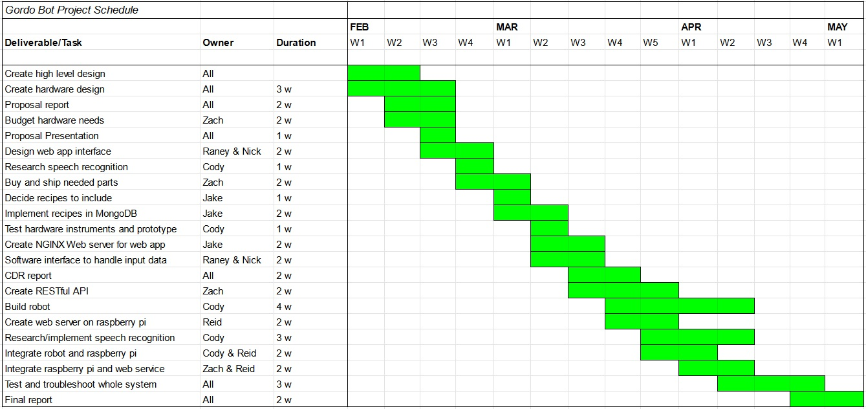

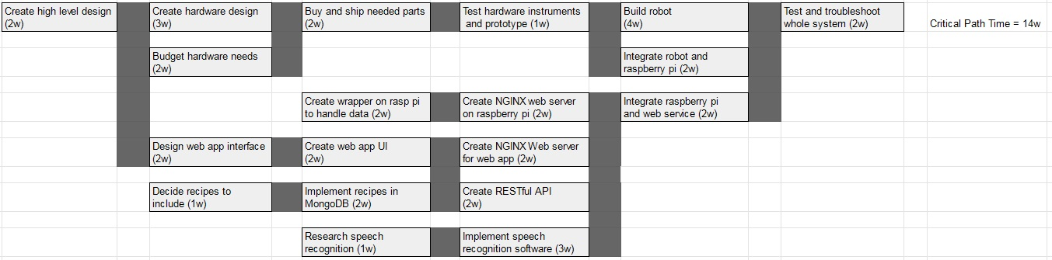

## Updated Validation and Testing Procedures

After all components (the front-end, server, database, hardware, etc.) are confirmed to be independently functional, the systems will be combined and a basic test will be performed using the complete flow of the device with each member verifying that their component behaves as expected. In general, the flow will start with user input on our Angular Web to our interfacing API. The Spring API communicates with our NGINX web server, pulling the necessary data from our MongoDB Database. The web server then sends the data to the Raspberry Pi. The Pi parses the data, using CircuitPython to perform the action that completes the indicated task. The flow chart below visualizes this general flow.

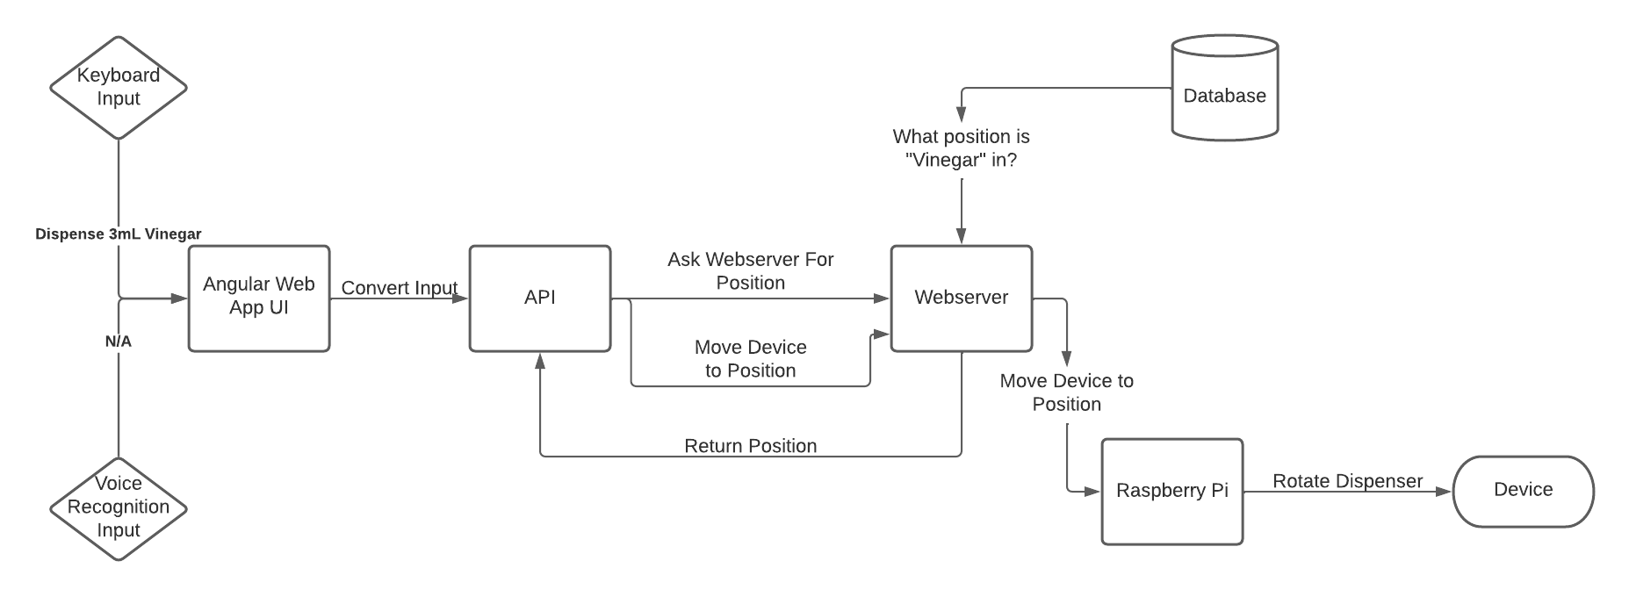

In our initial tests, the team member responsible for a given step in the flow verifies that the component took in the correct inputs and gave the expected outputs. The behavior for each step should be verified. For example, the Raspberry Pi should receive a JSON to parse from the web server. The person responsible for the Raspberry Pi interfacing should check that the JSON file is formatted correctly and that the Pi correctly parses/enacts the contents of the JSON. These initial tests are taken slowly to ensure the design works together as a unit. This stage is only expected to complete very basic “recipes,” such dispensing 1 cup of water. After the basic flow works correctly, then the next stage of validation occurs.

This stage of validation can be considered the “controlled” use case, meaning that the device is used in it’s expected manner, but with very specific recipes. At this stage we will use hand curated recipes with relatively simple steps and use the device how a user might. The recipe’s steps at this point should only contain tasks that can be performed by the Raspberry Pi and its IO. In practice, this is dispensing different variations of ingredients with varying amounts of each ingredient. The system will be looked as a whole at this point and is only considered validated if it functions correctly from start to finish. This means the device should be able to allow a user to select a recipe and have that recipe produced exactly as described) If something fails, then we trace the steps and identify the cause, alleviating the issue and trying the test again.

For the final stage of validation, the device should be fully functional. At this point users should be able to choose more complex recipes that require user intervention (such as baking the ingredient mix after it has been dispensed). The user should be able to seamlessly continue recipes after these steps and have the device perform the next step. Validation in this stage is considered successful if a user is able to choose a complex recipe, follow the steps provided, and successfully cook the recipe.

To ensure the device satisfies the need, a few random users can be given the device to cook a recipe. After using the device, the users will be asked to provide feedback, specifically if they felt this device made cooking easier and convenient.

## Updated division of labor and responsibilities

Reid: Software/Hardware Integration

* Create web server on Raspberry Pi (3/25)
* Integrate API with robot commands (4/8)
* Integrate API with entire web service (4/15)

Cody: Hardware and Sensors, Notetaker

* Create servo and sensor control software (4/8)
* Build physical robot (4/15)

Jake: Cloud Services and Communication

* Create server for web application (3/25)
* Implement recipes in MongoDB (4/1)

Raney & Nick: Website Designers

* Implement designed website (3/25)
* Integrate website with project (4/8)

Zach: API Design, Project Management

* Create API JSON templates (4/1)
* Implement API usage across system (4/8)

# Preliminary results

We have set up the NGINX server which will be used in order to handle the connection between the user interface and the Gordobot. The server is currently running and is ready for implementation.

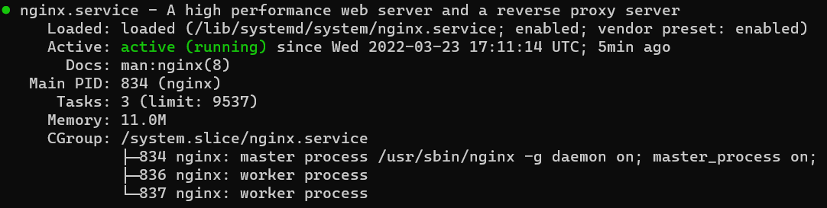

MongoDB was set up which will be used to store recipe info as well as the state of the device.

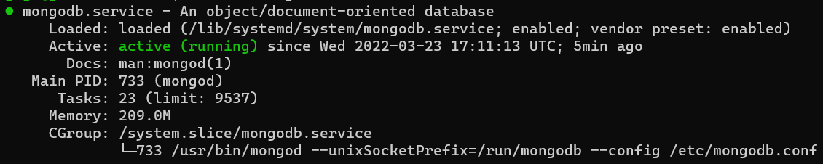

1. **References**
2. Hunter PR, “America keeps on cooking,” *America Keeps On Cooking*, 14-Jan-2021. [Online]. Available: https://www.prnewswire.com/news-releases/america-keeps-on-cooking-301208005.html?tc=eml_cleartime. [Accessed: 20-Feb-2022].
3. “Raspberry Pi Documentation.” Raspberry Pi.  
   Available:  
   https://www.raspberrypi.com/documentation/computers/